  - An introduction to technology creation through web development.
  - Module 2: CSS: Styling the webpage

Background:

What is web development?
Phones have apps that we can download from the app store but sometimes, we do not want to have to download apps to use software. Some apps also work on the internet browser on our phones and computers. We can use them by going to their website like facebook.com. Systems that work in an internet web browser are called websites and webapps.

Websites and Webpages.
A website refers to the whole system such as facebook.com. A website can be made of one or more webpages. For example, on Facebook, the screen changes completely when you look at someone’s profile when compared to just the Facebook feed. Each one of these “screens” are usually different webpages.

What are browsers?
Internet browsers are apps on phones and computers that can run websites. These include Google Chrome, Firefox, Microsoft Edge and any browser that comes with a phone or computer.

How do we build websites?

HTML
We can use a language called HTML to build websites. HTML stands for HyperText Markup Language. It is made up of html “tags” that describe what the website looks like. The web browser like Chrome, Firefox, and browsers on our phones read and understand the HTML we write to build the website. HTML is for creating the skeleton of the web page

CSS:
Using HTML to create the structure is not enough. We need to make sure that the webpage looks good so that people want to use the website. We use CSS to add colours, change sizes of html elements and control everything else to do with the looks of the webpage. We call the process of using CSS to change the look of the page “styling” our webpages.

Syntax
We use a combination of tools and programming languages to create websites. Each language and tool has rules that we must follow so that the browser understands the instructions we are giving it. We call the rules that we follow to write a programming language the “Syntax” of the language. HTML uses tags and elements. The tags and elements are the syntax of HTML. If we do not write them correctly, the browser will not understand what we are trying to do. We learned the HTML syntax and now we will learn the CSS syntax as well.

Introduction to CSS.

What is CSS?
CSS stands for “Cascading Style Sheets.” It is the language for describing the presentation/look of Web pages, including colours, layout, and fonts, therefore making our web pages presentable to the users. If we break up the acronym (css), we get:
- Cascading: Falling of Styles – means top to bottom.
- Style: Adding designs/Styling our HTML tags
- Sheets: Writing our style in different documents

How do we add CSS?
CSS can be added in 3 ways.
- Inline CSS
- Internal CSS
- External CSS

Inline CSS
In the HTML chapter, we explored html-elements that have “attributes.” These included the src attribute of the <img></img>, the href attribute of the <a></a> and the type attribute of the <input/> elements. We learned that the attributes provide the browser with extra information about the HTML element we are placing on the web-page. This includes things link where to find the image we want to show, the direct link for the <a></a> element and what type of input to accept from the user.

All HTML elements have a special attribute called “style” which we can use to tell the browser how to decorate the element. This is one of the ways we can tell the browser how to make the elements look. For example, the image below shows two <h1></h1> elements. The first one does not have a style attribute but the second one has a style attribute that changes the colour of the text to blue.
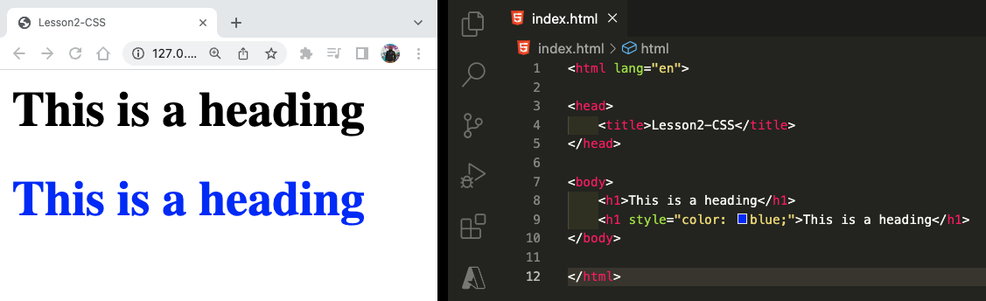

CSS Syntax
Just like everything else in programming. The way we write CSS has rules. As mentioned earlier, these rules are known as the syntax. CSS has a lot of properties that allow us to change different parts of the elements. The color property is just one of them. It is important to note that color is written using the American spelling (without u in colour). The syntax follows a simple pattern of “[property] : [value];” where property is the part of the element we want to style and value is how we want to style it. In our previous example, we see that the color is the property and blue is the value. The property and value are separated by a colon (:) and the line is ended by a semicolon (;)

color : blue ;
CSS Property
colon
value
Semicolon

Repeating styles.
The example in image 1 above only change the colour of one <h1></h1> element to blue. If we had 5 elements that we wanted to make blue, we would have to copy the style to all 5 elements like this:
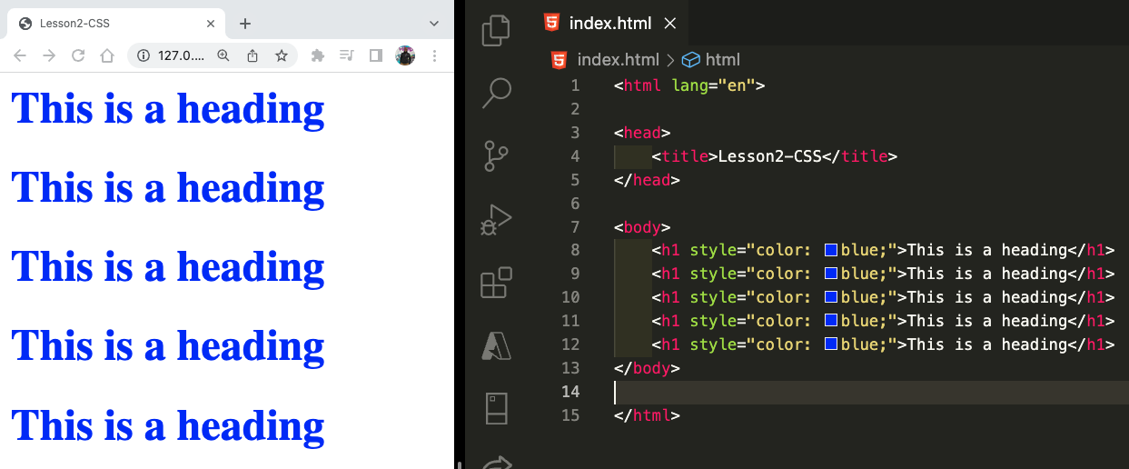

We see from image 2 that copying the 5 styles works as expected but if we now decided to change the colour to green, this means that we would have to change the code on 5 different lines. This is not a good approach. Copying the styles 5 times is a lot of work and because we know things always changing, updating them will take even more time. As engineers, we want things to be simple. Luckily for us, html allows us to write our scripts in one place, away from the html elements and in a way that tells the browser which elements we want to style. To do this, we can add a <style></style> element in the <head></head> part of our HTML. This is the second way we can add styles to our HTML. The first way was called in-line styling and we can call this internal styling.

Internal CSS
Internal styling/CSS is a term we use to describe adding CSS in the <head></head> of our html. This allows us to change all the styles in one place so we can easily see when things are going wrong. It also helps us write code once so we do not repeat ourselves. The image below shows how we can add this style tag.
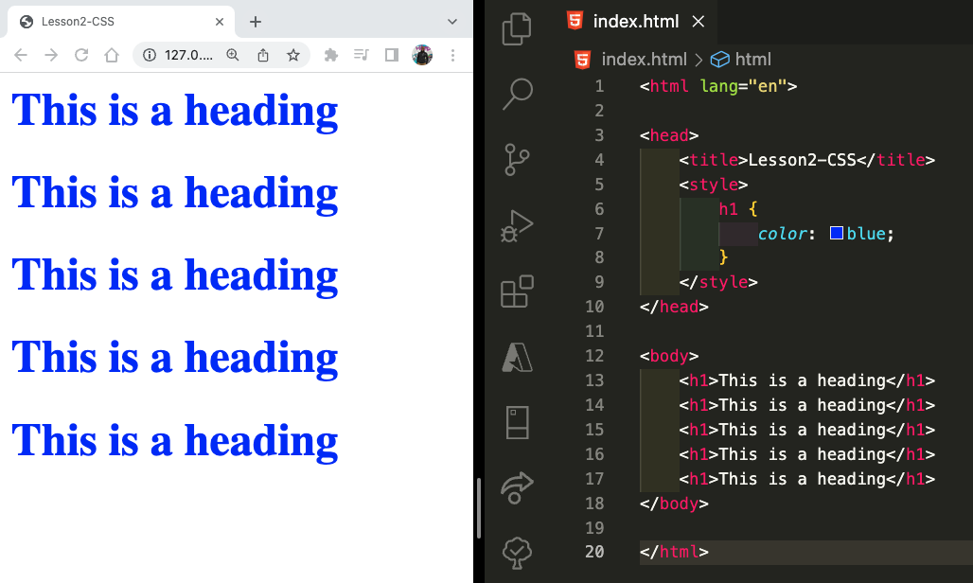
Image 3 above achieves the same result but with less code because we did not have to copy the styles. Now, if we want to change the colour from blue to red, we only change it one place. In the image, we see that in the <head><head> of our html, we added <style> opening and closing tags. This tells the browser that we are going to give it information on how to style html elements that are in the <body><body>. From the image we also see that inside the <style></style> element, we give the browser information of how to style. In this example, we told it to find all the <h1></h1> elements and change color property to blue. That’s why we see all of them changing to blue.

In this example, we also introduce curly-brackets which we will use a lot in programming. We followed specific CSS syntax to tell the browser to do this. We already know that by writing “color: blue;” we tell the browser to change the colour of the text to blue. But how did it know to do it to the <h1></h1> elements? We used a part of the CSS Syntax called CSS Selectors to tell the browser what to change.

CSS Selectors
CSS is the rules we give to the browser to tell it how to make things look. In the above example, we only have one rule. The rule tells the browser to change all <h1><h1> color to blue. Each rule must start by saying which element we want to change. This is called a selector in our example above, we said we want the h1 selector. After the selector, we use curly brackets {} to tell the browser that all the styling inside the curly brackets must be applied to what we have selected.
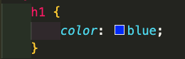

Selector: says what we want to change
Curly-brackets {}: Shows Start and end of styles to apply to selected elements

Multiple styles
In the above example, we only added one style. We changed the colour of the text to blue. Sometimes we need to change multiple styles to get the looks we want. To do this, we simply added another line inside of our CSS Styles. For example, if we want to make the background-colour of the <h1></h1> change to green and the text colour white, we simply do the following:

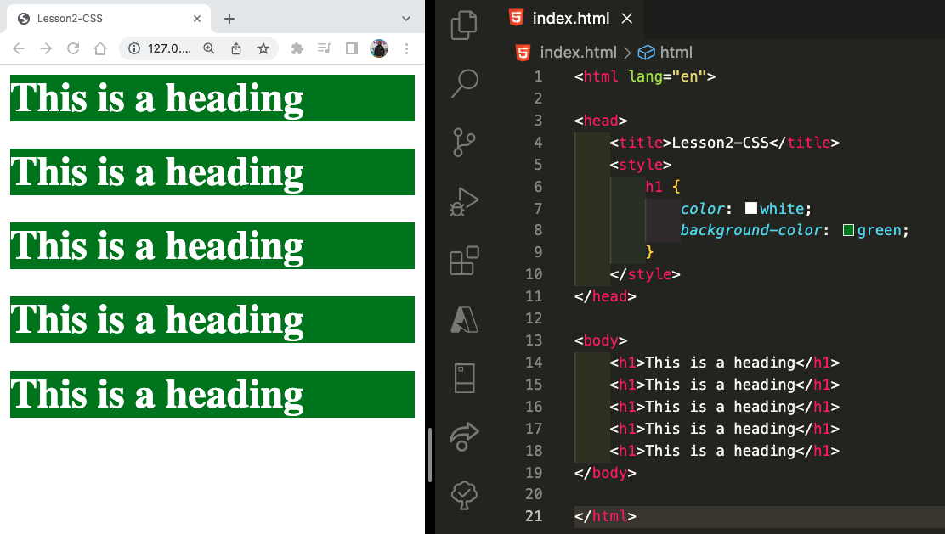

More CSS Selectors
So far we’ve only seen one selector: the h1 selector which selects all the <h1></h1> HTML elements. We can select any of the HTML element we know like this. For example if we change the html to only have one <h1><h1> and one <h2></h2> element, we get the following (since the style only applies to h1 and h2)
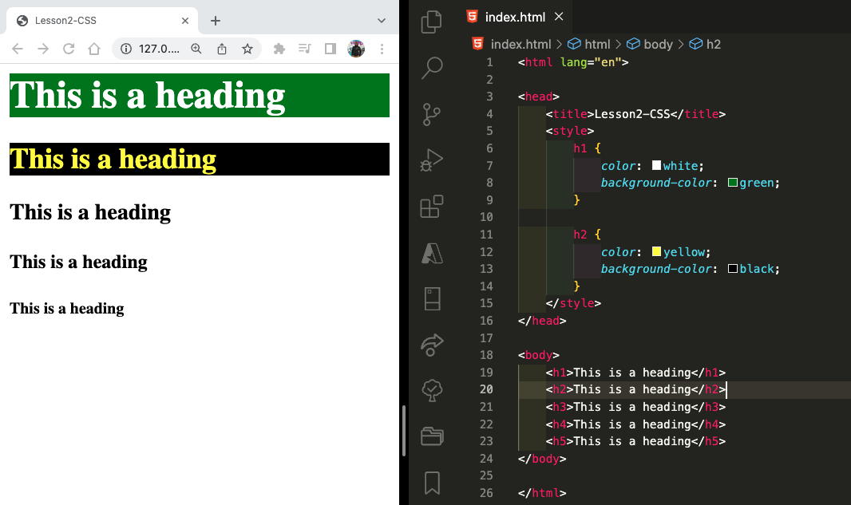
Here we see that the html changed to have h1, h2, h3, h4 and h5 but we only style h1 and h2 so the others stay the same. We can select them using h3, h4 and h5 selectors. You should notice the pattern here that we can use a selector that matches the html tag name. We can do this with any element. Which means we can use the p selector for <p></p>, the a selector or <a></a> and so on.

Class Selectors
The selectors we’ve seen so far select all the HTML elements that match the selector. If we use, h1, we select all the h1’s on the page. Sometime we want to change only some of the elements and not all of them. This means that we cannot use the h1 selector. Sometimes, the things we want to change are also different elements. For example, we might want to select a special <h1></h1> and 2 special <p></p>s to make them white with a green background. The selectors we know cannot help us here.

To do this, we need to use another HTML attribute know as class. The class attribute lets us give html elements extra information so that we can select them in the CSS. Look at the following example:
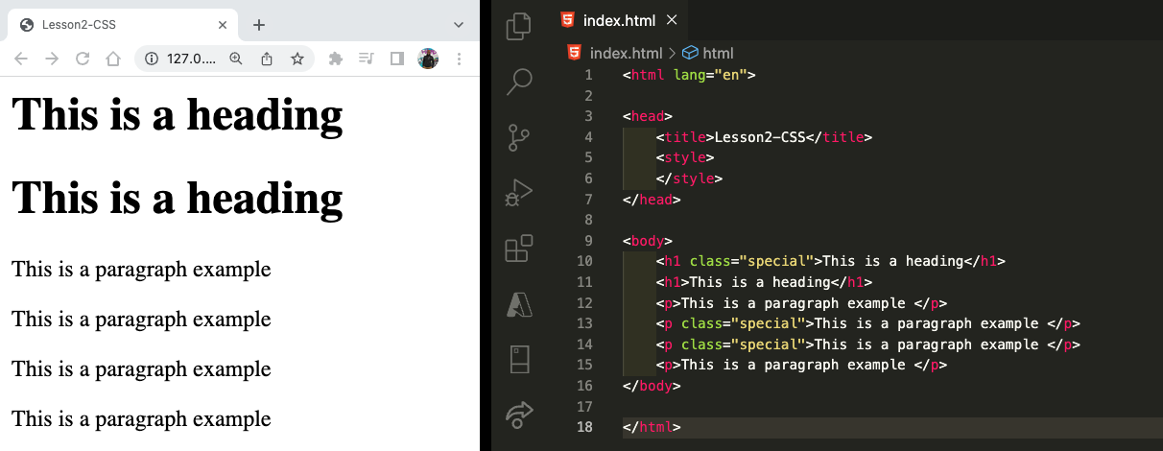
In this example above, we see that we have 2 <h1/> elements. Only one of them has the class attribute and it set to “special.” We also have 4 paragraph elements but only 2 of them have the special class. We also see that the <style></style> element in the head is empty so no styles are applied to any of them. This shows us that adding a class to an html element does not change anything. It just gives us another way to select that element in the CSS but it is the CSS that actually changes the look of the HTML element.

We selected the html elements by name just by writing h1, p, img and so on but to select elements by their class name, we need to put a dot (.) before the class name. So, if we want to make all the HTML elements with the class=“special” look blue on a gold background, all we have to do is select the class using (.special) and within the curly brackets, add the background-color and color changes as before and it would look like this:
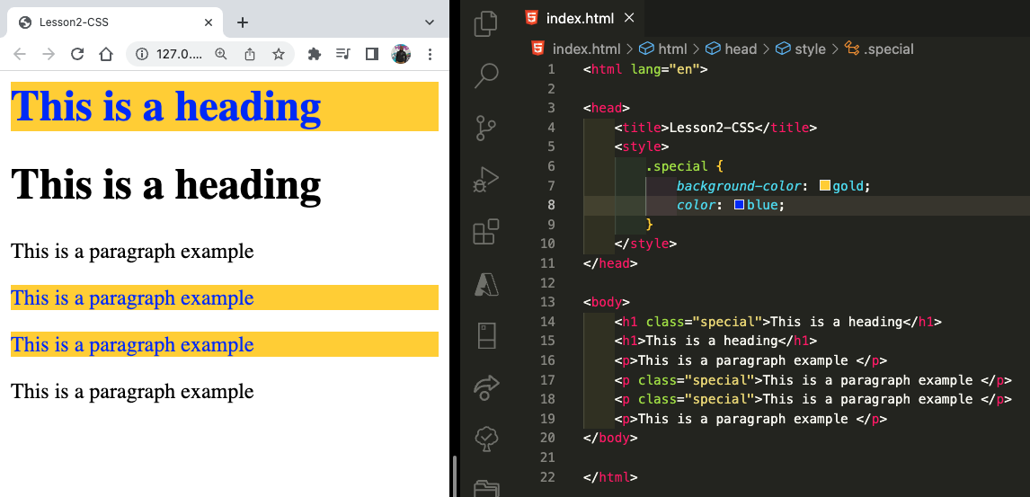

CSS Properties of elements
So far we’ve only been changing colours of the text and the background. CSS lets us change so much more. Some of the simple things we can change include the borders around elements, the font size and even the size of elements. Some properties will only apply to some elements and not others. For example, an image cannot have a font-size because it does not have text on it. So if you set font-size on an image element, you will not see any difference.

CSS Sizes
Some elements’ job is to show text (like h1, h2, and p). Size is a big part of this because we can make the text have different sizes. Since we build websites that work on computers, tablets and phones of different sizes, we measure sizes on a webpages in different ways. We can use % (a percentage of the available space) and px (pixels on the screen).

CSS Properties of text-elements
Since font is used a lot on webpages, CSS also provides standard font-sizes or us to use. For example, we can have paragraphs with different font sizes as show in the image below:
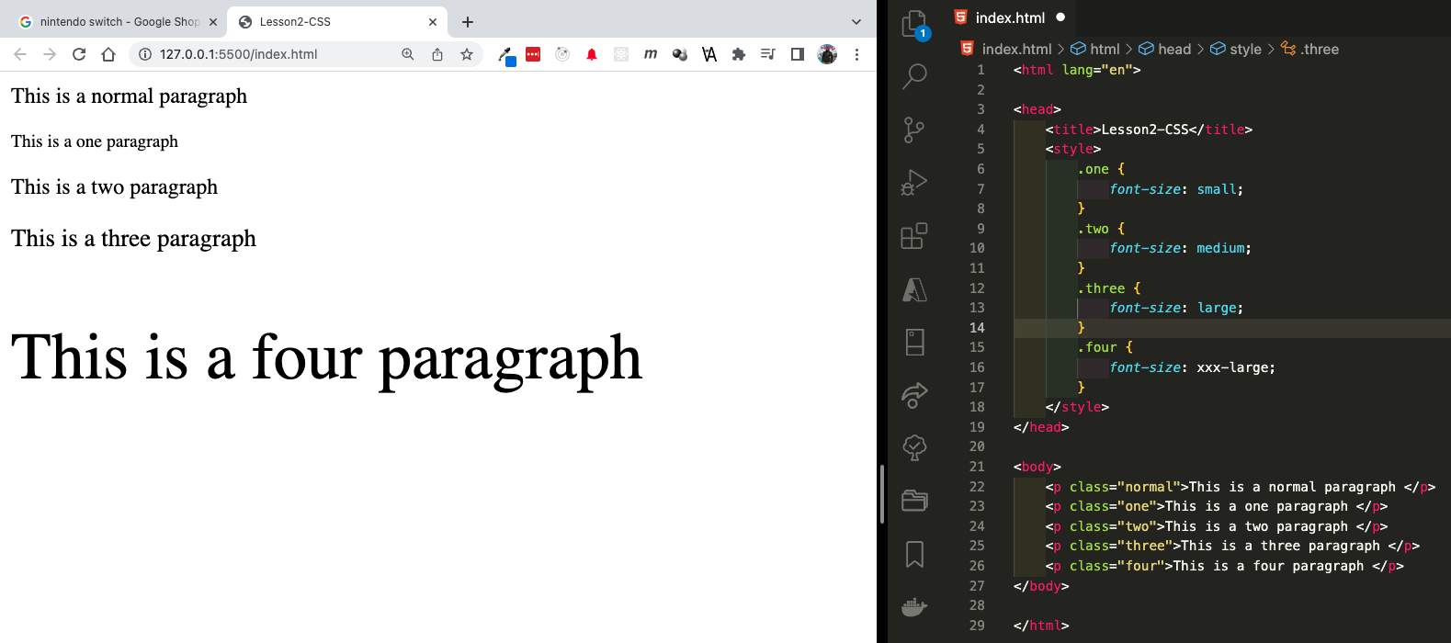
In the example above, we use small, medium, large and xxx-large as font sizes. The first paragraph has a class of “normal” and we did not provide any CSS for that class so it appears as a normal paragraph on the page. The other paragraphs are changed by the CSS we wrote for each of their classes. The size values we can use are:
- font-size: xx-small;
- font-size: x-small;
- font-size: small;
- font-size: medium;
- font-size: large;
- font-size: x-large;
- font-size: xx-large;
- font-size: xxx-large;

CSS Borders
Sometimes we need to clearly mark the sections of our webpage. A border around the HTML elements can be a simply way to do this. CSS has a property called border that we can use to do this. The following images show us examples of a box with text and a border around it
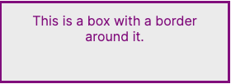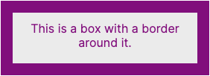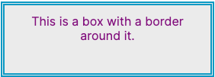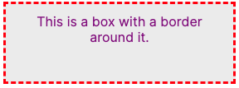
The four boxes above are very different. If we look at them carefully, we see that the text is the same, the background-color of the box is the same and that the font-size and color of the text are all also the same. The only difference is the border. The border is different because of three main things:
- Size (width) of the border: This is clearly seen by comparing the top two boxes.
- Border-style: Some borders have a solid line, two line and some even have dashes;
- Colour (color) of the border.
Since we can see these three main differences, it means CSS has properties for us to change all three of them and for any border we create, we must tell the browser these three things so it knows exactly how to draw our border. Below is a list of properties we use to control the border size (width), the style of the border line and its colour. Each property has different types of values. The border uses px (pixels) as explained in the CSS Sizes section above.

Part of border | CSS Property | Values | example
Size (width) | border-width | Px (pixels) | border-width: 2px;
Style of line | border-style | dashed, dotted, double, solid | border-style: solid;
Colour | border-color | Colours black, red, green, etc) | border-color: black;

If take our earlier example which had 4 paragraphs, we could add a background-color and a border around one paragraph by specifying the size, style and colour of the border. If we choose 2px, dotted and blueviolet, this is how it would look.
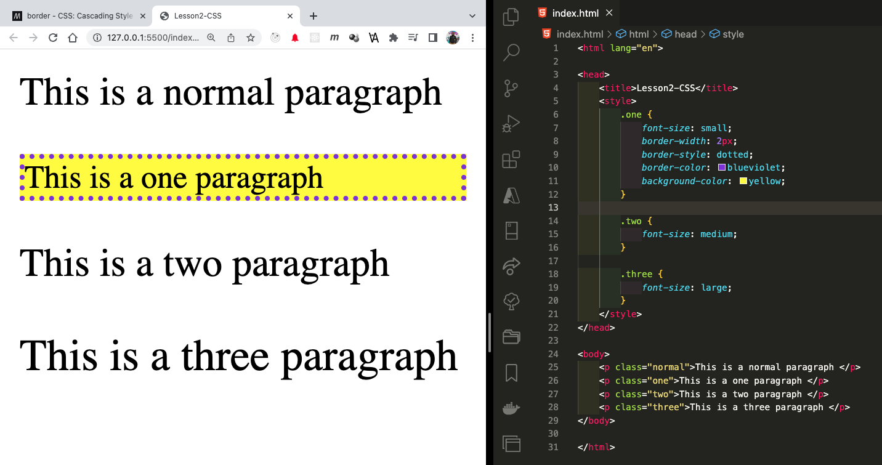

Aligning Text
Now that our one paragraph has a border, we might want the text to be in the centre to make it look nicer. This usually what we do with headings. We can put our text against the left or the right of the page or even the centre of a page. This is called “text alignment.” In CSS we can change the alignment of the text by changing the text-align property and setting it to center. Here’s an example below: Our one paragraph now has text aligned to the centre while the rest are still aligned to the left of the page
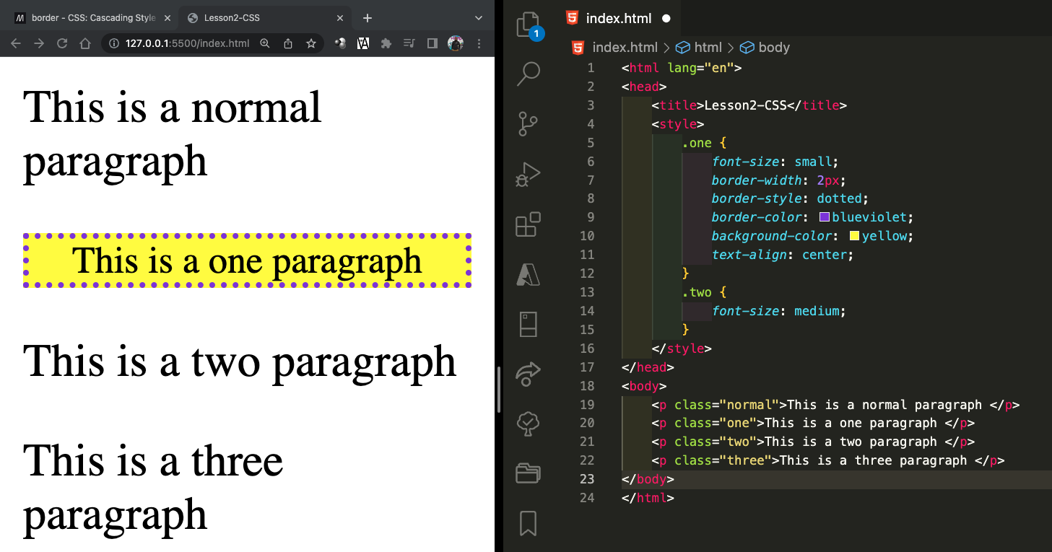
On a bigger screen, if we also center the two paragraph, this is what it all looks like:
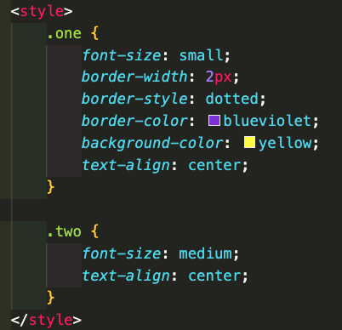
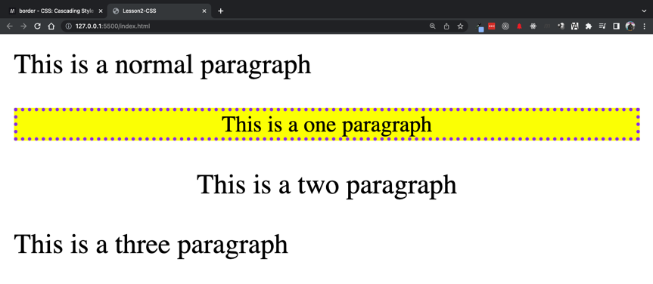

From the above images, we see that text-align is the only CSS Property that is making the text center align. The rest of the paragraphs don’t have this change so they stay left-aligned.

Styling children with Div.
In the HTML module, we learned about the <div></div> element which we can use as a container to group other HTML elements together. For example, we can group the one and two paragraphs together inside of a <div></div> element. We can also add the class attribute to the <div></div> element which means that we can add CSS to the specific div elements as well. Look att how we use divs in the example below:
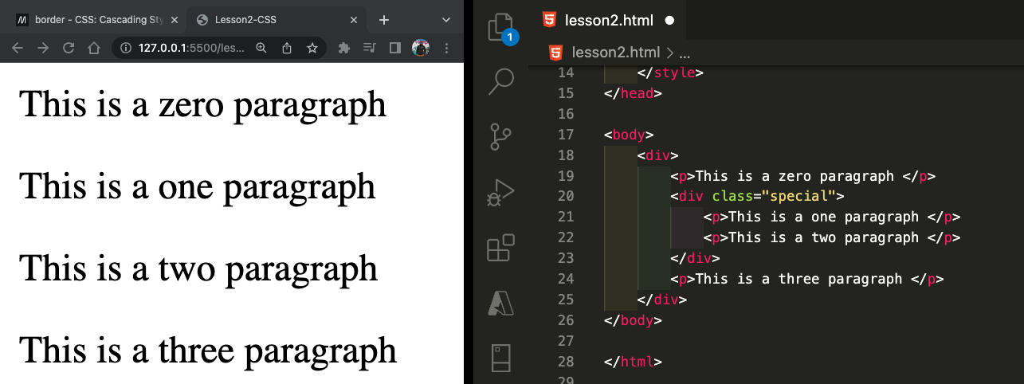
In the image below, we have added to divs. The first one (on line 18) ends on line 25 and has all the paragraphs inside of it. We call all the HTML elements that are inside of another HTML elements the children of that main element. So in the image above, the div that starts on line 18 and closes on line 25 is the parent of all the children elements between lines 19-24. This is important to understand because CSS allows us to control all the children of an HTML element by controlling the parent element.

Using the div selector, we can add a border around all divs in the page so we can see them on the screen. If we add a black solid border, with a width of 3px with the below code, we get the following:
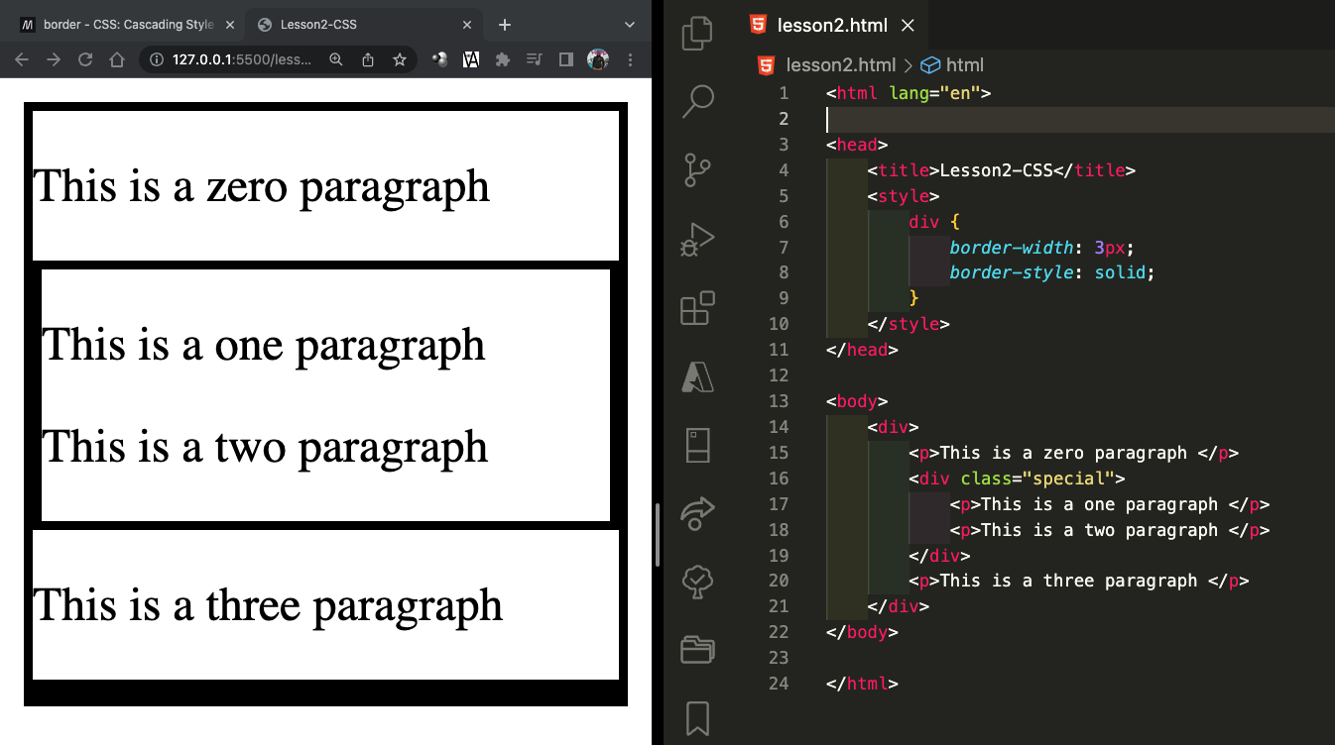
In the image above, we see that there is one border around all the paragraphs combined and another just around the two inner paragraphs so we see that we can style all the divs on a webpage just like any other HTML Element.

The inner div has a classname “special.” This means that we can select that div specifically to style itdierentlt. If we centre-align the text on this special div, CSS will center all the children elements that are inside the div. The following image shows an example of this.
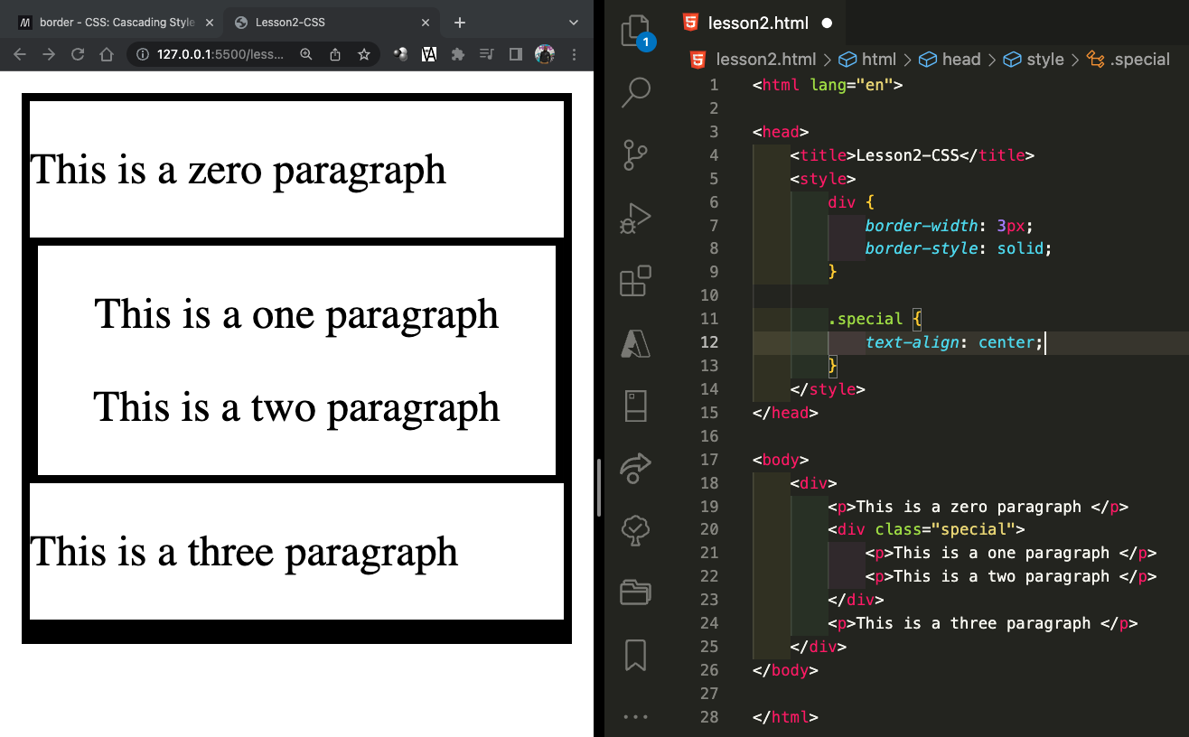
Now we see that the two paragraphs in the middle (which are children of the “special” div) are now centred while the one others are not. This doesn’t only apply to paragraphs. We can add an image to the special div and because we centred the div itself, the image will be in the centre as well and if we put it outside of the special div, it goes to the left of the page.
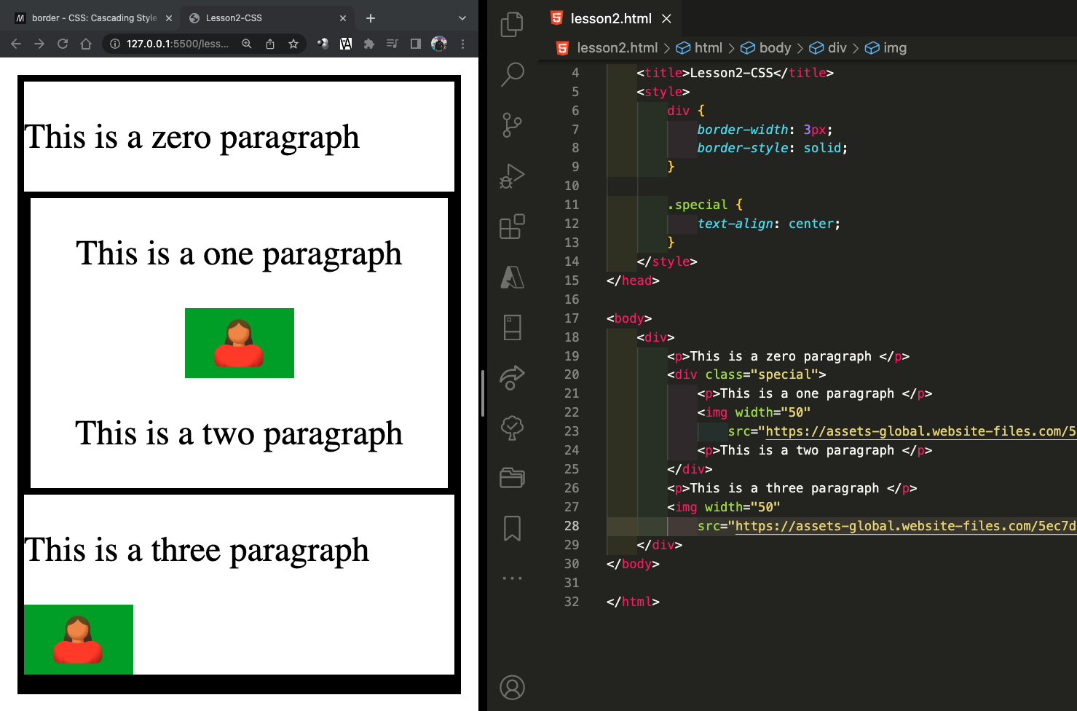

Keywords to explore
This document uses a lot of words that you might not know. Make sure you learn any word you don’t know. Some of the important words are:
Keywords | Your understanding/explanation
attributes
CSS
Syntax
Website
Webpage
CSS Selector
CSS Property
Parent Element

Child Element

Assignment 2
On paper, with a pencil, and using the HTML elements and CSS you learned here, write down the HTML needed to create a website that looks like this:
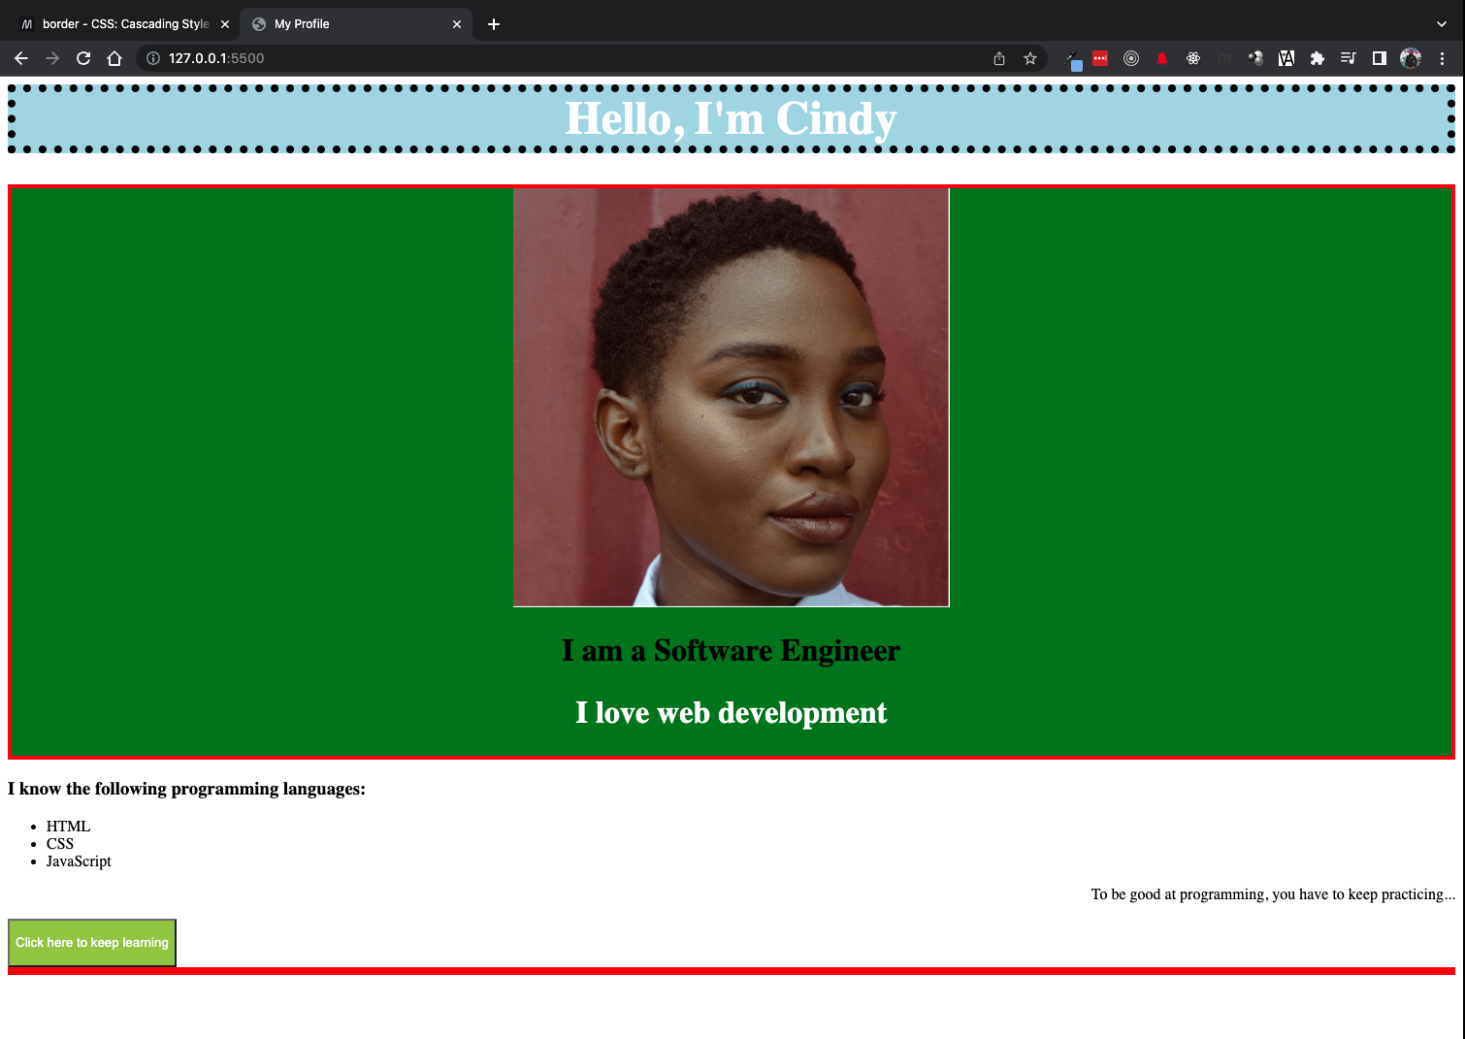
Image from: https://unsplash.com/photos/J1OScm_uHUQ

You can use your own name and picture but the styling must be the same.
You can also write the CSS on a different page.

